# 11/12/2022 Hallowed Be Your Name

### (Exodus 3 :13-15)

By David XU

When I first became a Christian, I was troubled by one thing “what is God’s name?” The Bible I use has both Chinese and English in it. On English side it reads “LORD”, on Chinese side it reads “耶和华“--yehowah”. Which one is right? “LORD” or “耶和华Yehowah”, sounds totally different.

Being an ignorant new Christian at the time, I asked other new Christian around, they all seemed as puzzled as I was. Someone said maybe both were right, maybe in Chinese He is called “耶和华Yehowah”, and in English “LORD”, like many Chinese have English names. I wasn’t convinced. So I kept searching for the answer, then someone said that Bible was written in English, we should pronounce God’s name according to English version. Well being an English teacher before, this sounded more convincing.

You see, for a long time in my early days of Christian life, I had no idea how to pronounce God’s name properly. Until one day, I read the first few pages of Bible with smaller letters, it explained that “LORD” is used for “Yahweh” or “YHWH”. That was like a lightening to me – Bible was not written in English. Later on, as I kept studying, I know majority of Bible was written in Hebrew and Greek. I also found out, Chinese version was translated directly from Hebrew and Greek version. “耶和华Yehowah”, pronounced more closely to original txt than “LORD”.

## Why name is important?

You may wonder, why name is important? Isn’t it just a symbol?

Well name is important, at least in the Bible. God changed Abram to Abraham to fulfil His purpose. God changed Jacob to Israel. Jesus changed Simon to Peter, Saul to Paul. It seems that when God has a purpose for them, He needs to change their name first so that they can fulfil that purpose. Like “Abram”, it means “exalted Father”. God needed to change it to “Abraham”—meaning “father of Nations” to fulfil his mission. The meaning of the name is important to God. It is more than just a symbol. So brothers and sisters, think about our names, what our names meaning are, what purpose shall God achieve in our life. How can we live out the meaning of our names?

If God think our names are important, how about His name? As children of God, shouldn’t we know His name -- the meaning of His name, how to read it correctly?

Many Godly men in scripture knew the importance of God’s name, like Abraham, Moses, King David and many others

 “there he (Abraham) built an altar to the Lord and called on the name of the Lord. “(Gen 12:8)

King David “Oh, give thanks to the Lord!(YHWH)

Call upon His name;

Make known His deeds among the peoples!” (1 Chronicle 16:8)

I love the Lord, because He has heard

My voice *and* my supplications.

Because He has inclined His ear to me,

Therefore I will call *upon* *Him* as long as I live.

The pains of death surrounded me,

And the pangs of Sheol laid hold of me;

I found trouble and sorrow.

Then I called upon the name of the Lord:

“O Lord, I implore You, deliver my soul!” (Psalm 116 : 1-4)

We can see from these scriptures, they all called on the name of the Lord. But if you don’t know the name of Lord, you don’t know the meaning of His name, how can you call upon Him? Today I am trying to explain the meaning of God as much as I can. I know His name has such a profound meaning that I would never be able to explain in full. I am only doing my best to reveal a tiny portion of it. I am open for different views and correction if I am wrong.

## What is your name?

Now let’s get into today’s scripture.

“Then Moses said to God, “Indeed, *when* I come to the children of Israel and say to them, ‘The God of your fathers has sent me to you,’ and they say to me, ‘What *is* His name?’ what shall I say to them?”

Moses didn’t know God’s name at the beginning. He might have some idea, that his ancestors had a God. But who was this God, how did He look like, what his character like? Moses had no idea. The whole Israelites people had no idea either.

It is a pity Abraham’s descendants had no concept of this God. We actually can see this memory lost paten happened in Bible many times. Adam and Eve knew God, but to Noah’s age, people completely ignorant about God, did all evil things. God had to destroy them. Abraham knew God, followed God, God called him “my friend”, after a few hundred years, Israelites didn’t know about God. God raise Moses to save them. Not long after Joshua’s, Israelite rebel against God again. Then God raise King David, “the one who after His own heart”, not long after David, they forgot God again. Look at today’s world, the countries once were built on the foundation of Gospel, how many people in these countries still know God? Human history is a cycle. It repeats itself.

So Moses question is a valid one. You gave me a big task, to pick on a fight against the most powerful man in the world at the time. But I don’t know you. Who are you? What power do you have? Why should I listen to you and risk my life? Please tell me your name. Because name has meaning, from the name, Moses maybe able to get some understanding of this God. By finding out God’s name, Moses could have felt a bit comfort in this journey.

Once we understand the meaning of our God’s name, you will remember it for your life, you will teach your children, and they will remember for their life.

## I AM Who I AM

“And God said to Moses, “I AM WHO I AM.” And He said, “Thus you shall say to the children of Israel, ‘I AM has sent me to you.’ ”

God told Abraham that He is “I AM”. The “I AM” is a rather a description of the character of God. Because He is self existence, everlasting, He is the beginning and the end.

Later in verse 15, God gave Moses His name “‘The Lord God of your fathers, the God of Abraham, the God of Isaac, and the God of Jacob, has sent me to you. This *is* My name forever, and this *is* My memorial to all generations.’ If we read Hebrew txt, we read “Lord” as YHWH. (PPT, in Green). God wanted us to call him YHWH.

So YHWH is I AM, is the beginning and the end, the Alpha and Omega. He is the one in Genesis1:1, and the same one at the end of Revelation.

Hebrew is a unique language. It is alphabetic, numeric, and Hieroglyphs. Each Hebrew letter has a pronunciation, a numeric value, it is also a picture.

YHWH meaning, Picture.

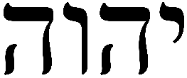

Hebrew letter for God’s name is

First Letter is “yod” is written like a “hand”, meaning “hand”

Second Letter and 4th one is “He” --“window”, meaning “to reveal”, to “look”. It is used in a similar way as “the” in English

Third letter is “Vav” – “nail”

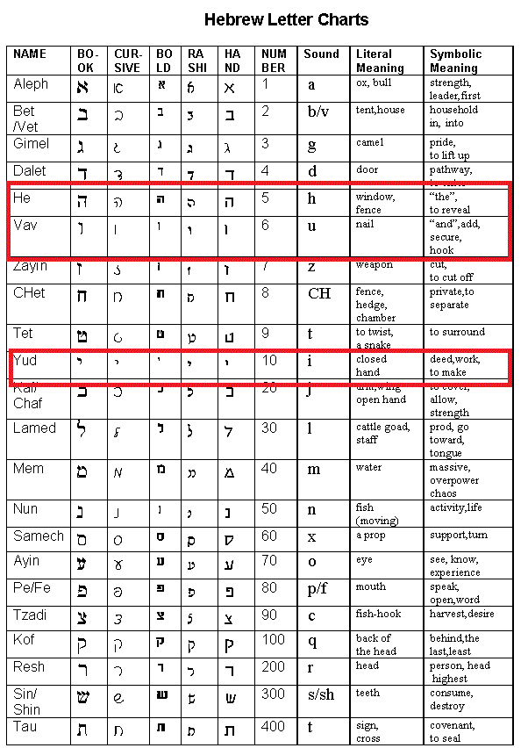

Now let’s put these meaning together

Hand-look-nail-look.

YHWH, the God that create the heaven and earth, that sustain all things, that so love the world, has mark of nail on his hand. This great I AM, that from Genesis to Revelation has mark of nail on his hand.

And why He bear this mark on His hands? It is all because our sins, you and I all included. Sometimes we can’t understand the gravity of this sacrifice. Let me make an illustration, how would you feel if your earthly father was beaten, publicly mocked and killed because of your transgression, he sacrificed his life to save you. How would you feel?

God told Moses, my name is YHWH, one day I would save Israelites from Egypt, later, there would be a greater exodus, that I would come down in human form, I would be sacrificed as perfect lamb, that my body would be pierced, my blood would be shed for you. As a proof of my love to you, to all human beings that I created, to those who love me, I will wear the mark of nail forever. Every time you call my name, you shall remember the nail in my hands, you remember the sacrifice of perfect lamb.

Luke 9:30-31 “30Two men, Moses and Elijah, appeared in glorious splendour, talking with Jesus. 31They spoke about his departure, which he was about to bring to fulfillment at Jerusalem. “

Here “departure” in Greek is “exodus”. Jesus, Moses and Elijah were talking about the next Exodus—He will save entire human beings from slavery.

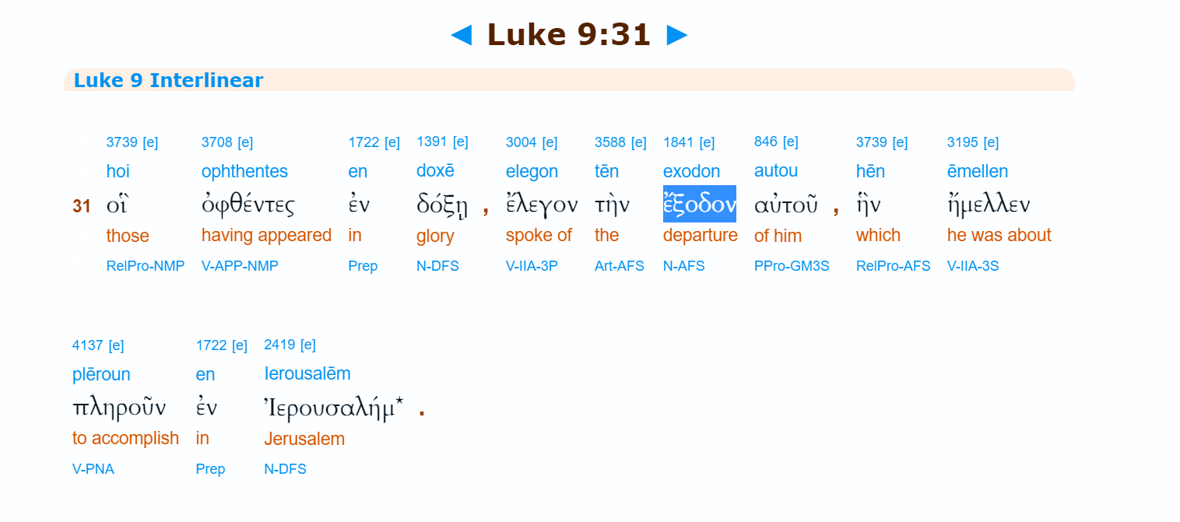

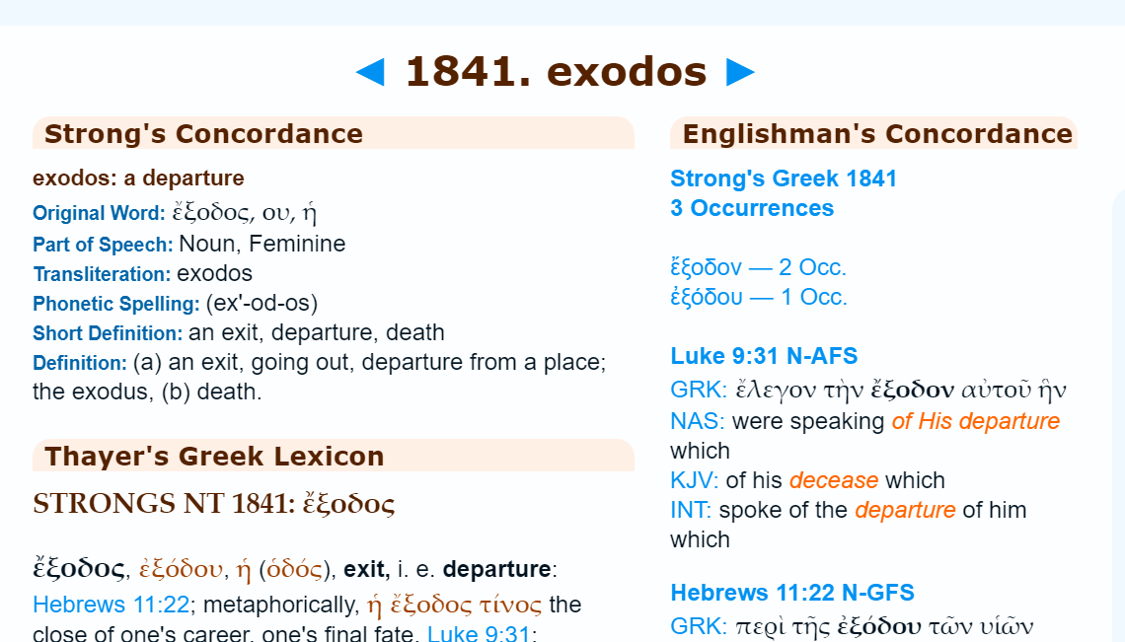

### Is Jesus YHWH

Is there any scriptures in New Testament saying Jesus is YHWH? Yes.

Let’s read

John 8:57-59 “57Then the Jews said to Him, “You are not yet fifty years old, and have You seen Abraham?”

58Jesus said to them, “Most assuredly, I say to you, before Abraham was, I AM.”

59Then they took up stones to throw at Him; but Jesus hid Himself and went out of the temple, going through the midst of them, and so passed by.”

Why did Jews want to kill Jesus? Because Jesus said “I AM”. Jesus clearly said here that He is I AM, He is YHWH, He is the one who has the mark of nail on His hand.

Let’s see another proof.

John 17: 11-12” 11I’m no longer in the world, but they are in the world, even as I’m coming to you. Holy Father, **watch over them in your name, the name you gave me**, that they will be one just as we are one. 12When I was with them**, I watched over them in your name, the name you gave to me,** and I kept them safe. None of them were lost, except the one who was destined for destruction, so that scripture would be fulfilled. “(CEB)

What name Father gave His Son? Yeshua, what does it mean? “God Save”. What is God’s name” YHWY”. Put them together, YHWH Save=The hand with mark of nail Save.

Now, I understand a bit more why Thomas wanted to see the mark on Jesus hands. He wanted to make sure that Jesus is the YHWH.

Look at this verse

“10“And I (YHWH) will pour out on the house of David and the inhabitants of Jerusalem a spirit of grace and supplication. They will look on me, the one they have pierced, and they will mourn for him as one mourns for an only child, and grieve bitterly for him as one grieves for a firstborn son. “(Zechariah 12:10)

The prophet told people that one day they would pierce God.

## The power of God’s name

Now we know the name of our God, let’s see what power His Name has.

John 18 : 4-5 Jesus therefore, knowing all things that would come upon Him, went forward and said to them, “Whom are you seeking?”

They answered Him, “Jesus of Nazareth.”

Jesus said to them, “I am *He.*” And Judas, who betrayed Him, also stood with them. 6Now when He said to them, “I am *He,*” they drew back and fell to the ground.

Ever wonder why Jesus asked them “whom are you seeking?”, though it is said in verse 4” Jesus therefore, knowing all things that would come upon Him?” Why did Jesus ask a question that he knew the answer?

Because He wanted them to ask this question, then He can answer “I AM He”.

As soon as Jesus said “I AM”, what happened , “they drew back and fell to the ground”.

That is the power of our God’s Name, enemy can’t stand to it.

In Luke Chapter 10, the 70 people returned from their mission trip, “The seventy-two returned joyously, saying, “Lord, even the demons submit themselves to us in your name.”.

Mark 16 “And these signs will follow those who believe: In My name they will cast out demons; they will speak with new tongues; 18they will take up serpents; and if they drink anything deadly, it will by no means hurt them; they will lay hands on the sick, and they will recover.” （Mark 16: 17-18）

Now, when we read Lord’s Prayer, do we have new understanding of “Hallowed be your Name?” Do we have deeper understanding of “you will be done” “forgive our debts”, “deliver us from the evil one”?

Our Father in heaven,

Hallowed be Your name.

Your kingdom come.

Your will be done

On earth as *it is in heaven.*

Give us this day our daily bread.

And forgive us our debts,

As we forgive our debtors.

And do not lead us into temptation,

But deliver us from the evil one.

For Yours is the kingdom and the power and the glory forever. Amen.